Mechanical Properties of Materials

**3**

**Chapter Contents**

* 1. **Stress–Strain Relationships**
     1. Tensile Properties
     2. Compression Properties
     3. Bending and Testing of Brittle Materials
     4. Shear Properties
  2. **Hardness**
     1. Hardness Tests
     2. Hardness of Various Materials
  3. **Effect of Temperature on Properties**
  4. **Fluid Properties**
  5. **Viscoelastic Behavior of Polymers**

Mechanical properties of a material determine its be- havior when subjected to mechanical stresses. These properties include elastic modulus, ductility, hardness, and various measures of strength. Mechanical proper- ties are important in design because the function and performance of a product depend on its capacity to re- sist deformation under the stresses encountered in serv- ice. In design, the usual objective is for the product and its components to withstand these stresses without sig- nificant change in geometry. This capability depends on properties such as elastic modulus and yield strength. In manufacturing, the objective is just the opposite. Here, stresses that exceed the yield strength of the material must be applied to alter its shape. Mechanical processes such as forming and machining succeed by developing forces that exceed the material’s resistance to deforma- tion. Thus, there is the following dilemma: Mechanical properties that are desirable to the designer, such as high strength, usually make the manufacture of the product more difficult. It is helpful for the manufacturing engi- neer to appreciate the design viewpoint and for the de- signer to be aware of the manufacturing viewpoint.

This chapter examines the mechanical properties of materials that are most relevant in manufacturing.

# Stress–Strain Relationships

There are three types of static stresses to which mate- rials can be subjected: tensile, compressive, and shear. Tensile stresses tend to stretch the material, compres- sive stresses tend to squeeze it, and shear involves stresses that tend to cause adjacent portions of the ma- terial to slide against each other. The stress–strain curve is the basic relationship that describes the mechanical properties of materials for all three types.

### 52

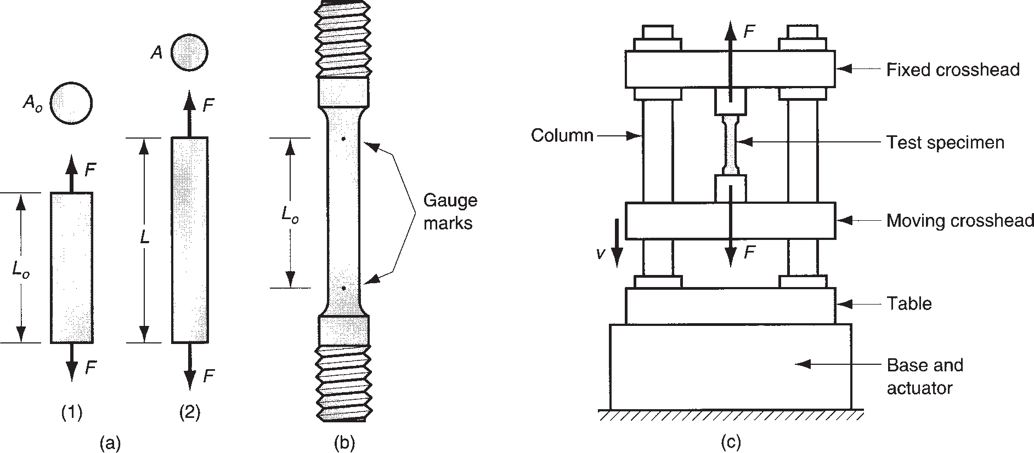

**FIGURE 3.1** Tensile test: (a) tensile force applied in (1) and (2) resulting elongation of material; (b) typical test specimen; and (c) setup of the tensile test.

## TENSILE PROPERTIES

The tensile test is the most common procedure for studying the stress–strain rela- tionship, particularly for metals. In the test, a force is applied that pulls the material, tending to elongate it and reduce its diameter, as shown in Figure 3.1(a). Standards by ASTM (American Society for Testing and Materials) specify the preparation of the test specimen and the conduct of the test itself. The typical specimen and general setup of the tensile test is illustrated in Figure 3.1(b) and (c), respectively.

The starting test specimen has an original length *Lo* and area *Ao*. The length is measured as the distance between the gage marks, and the area is measured as the (usually round) cross section of the specimen. During the testing of a metal, the specimen stretches, then necks, and finally fractures, as shown in Figure 3.2.

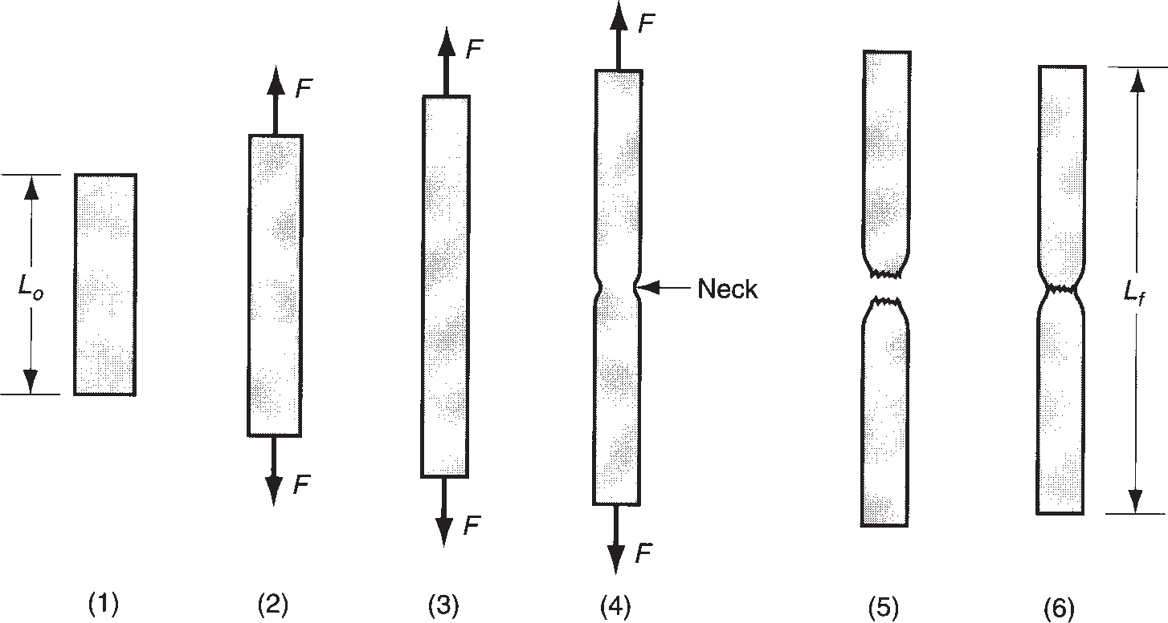

**FIGURE 3.2** Typical progress of a tensile test: (1) beginning of test, no load; (2) uniform elongation and reduc- tion of cross-sectional area; (3) continued elongation, maximum load reached; (4) neck- ing begins, load begins to decrease; and (5) fracture. If pieces are put back together as in (6), final length can be measured.

The load and the change in length of the specimen are recorded as testing proceeds, to provide the data required to determine the stress–strain relationship. There are two different types of stress–strain curves: (1) engineering stress–strain and (2) true stress–strain. The first is more important in design, and the second is more important in manufacturing.

**Engineering Stress–strain** The engineering stress and strain in a tensile test are defined relative to the original area and length of the test specimen. These values are of interest in design because the designer expects that the strains experienced by any component of the product will not significantly change its shape. The components are designed to withstand the anticipated stresses encountered in service.

A typical engineering stress–strain curve from a tensile test of a metallic speci- men is illustrated in Figure 3.3. The ***engineering stress*** at any point on the curve is defined as the force divided by the original area:

*s* =  *F*

*Ao*

(3.1)

where *s* = engineering stress, MPa (lb/in2); *F* = applied force in the test, N (lb); and *Ao* = original area of the test specimen, mm2 (in2). The ***engineering strain*** at any point in the test is given by

*e* = *L* - *Lo*

*Lo*

(3.2)

where *e* = engineering strain, mm/mm (in/in); *L* = length at any point during the elongation, mm (in); and *Lo* = original gage length, mm (in). The units of engineer- ing strain are given as mm/mm (in/in), but think of it as representing elongation per unit length, without units.

The stress–strain relationship in Figure 3.3 has two regions, indicating two dis- tinct forms of behavior: (1) elastic and (2) plastic. In the elastic region, the relation- ship between stress and strain is linear, and the material exhibits elastic behavior by

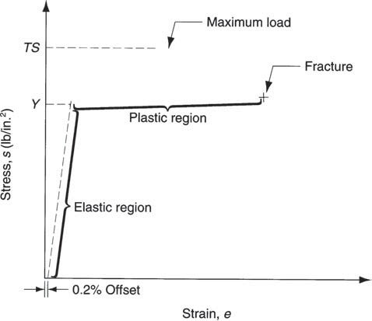

**FIGURE 3.3** Typical engineering stress–strain plot in a tensile test of a metal.

returning to its original length when the load (stress) is released. The relationship is defined by ***Hooke’s law***:

*s* = *Ee* (3.3)

where *E* = ***modulus of elasticity*** (also known as ***Young’s modulus***), MPa (lb/in2), a measure of the inherent stiffness of a material. It is a constant of proportionality whose value is different for different materials. Table 3.1 presents typical values for several materials, metals and nonmetals.

As stress increases, some point in the linear relationship is finally reached at which the material begins to yield. This ***yield point*** *Y* of the material can be identi- fied in the figure by the change in slope at the end of the linear region. Because the start of yielding is usually difficult to see in a plot of test data (it does not usually oc- cur as an abrupt change in slope), *Y* is typically defined as the stress at which a strain offset of 0.2% from the straight line has occurred. More specifically, it is the point where the stress–strain curve for the material intersects a line that is parallel to the straight portion of the curve but offset from it by a strain of 0.2%. The yield point is a strength characteristic of the material, and is therefore often referred to as the ***yield strength*** (other names include ***yield stress*** and ***elastic limit***).

The yield point marks the transition to the plastic region and the start of plas- tic deformation of the material. The relationship between stress and strain is no longer guided by Hooke’s law. As the load is increased beyond the yield point, elongation of the specimen proceeds, but at a much faster rate than before, caus- ing the slope of the curve to change dramatically, as shown in Figure 3.3. Elonga- tion is accompanied by a uniform reduction in cross-sectional area, consistent with maintaining constant volume. Finally, the applied load *F* reaches a maxi- mum value, and the engineering stress calculated at this point is called the ***tensile***

|  |  |  |  |  |  |  |  |
| --- | --- | --- | --- | --- | --- | --- | --- |
|  | **TABLE** • **3.1** Elastic modulus for selected materials. | | | | | | |
|  |  | **Modulus of Elasticity** | |  | **Modulus of Elasticity** | |  |
| **Metals** | **MPa lb/in2** | | **Ceramics and Polymers** | **MPa** | **lb/in2** |
| Aluminum and alloys | 69 X 103 | 10 X 106 | Alumina | 345 X 103 | 50 X 106 |
| Cast iron | 138 X 103 | 20 X 106 | Diamonda | 1035 X 103 | 150 X 106 |
| Copper and alloys | 110 X 103 | 16 X 106 | Silicona | 185 X 103 | 27 X 106 |
| Iron | 209 X 103 | 30 X 106 | Plate glass | 69 X 103 | 10 X 106 |
| Lead | 21 X 103 | 3 X 106 | Silicon carbide | 448 X 103 | 65 X 106 |
| Magnesium | 48 X 103 | 7 X 106 | Tungsten carbide | 552 X 103 | 80 X 106 |
| Nickel | 209 X 103 | 30 X 106 | Nylon | 3.0 X 103 | 0.40 X 106 |
| Steel | 209 X 103 | 30 X 106 | Phenol formaldehyde | 7.0 X 103 | 1.00 X 106 |
| Titanium | 117 X 103 | 17 X 106 | Polyethylene (low density) | 0.2 X 103 | 0.03 X 106 |
| Tungsten | 407 X 103 | 59 X 106 | Polyethylene (high density) | 0.7 X 103 | 0.10 X 106 |
| Zinc | 108 X 103 | 16 X 106 | Polystyrene | 3.0 X 103 | 0.40 X 106 |

aCompiled from [8], [10], [11], [15], [16], and other sources.

Although diamond and silicon are not ceramics, they are often compared with the ceramic materials.

|  |  |  |  |  |  |  |  |  |  |  |
| --- | --- | --- | --- | --- | --- | --- | --- | --- | --- | --- |
|  | **TABLE** • **3.2** Yield strength and tensile strength for selected metals. | | | | | | | | | |
|  |  | **Yield Strength Tensile Strength** | | | |  | **Yield Strength** | | **Tensile Strength** | |
| **Metal** | **MPa** | **lb/in2** | **MPa** | **lb/in2** | **Metal** | **MPa** | **lb/in2** | **MPa** | **lb/in2** |
| Aluminum, annealed | 28 | 4,000 | 69 | 10,000 | Nickel, annealed | 150 | 22,000 | 450 | 65,000 |
| Aluminum, CWa | 105 | 15,000 | 125 | 18,000 | Steel, low Ca | 175 | 25,000 | 300 | 45,000 |
| Aluminum alloysa | 175 | 25,000 | 350 | 50,000 | Steel, high Ca | 400 | 60,000 | 600 | 90,000 |
| Cast irona | 275 | 40,000 | 275 | 40,000 | Steel, alloya | 500 | 75,000 | 700 | 100,000 |
| Copper, annealed | 70 | 10,000 | 205 | 30,000 | Steel, stainlessa | 275 | 40,000 | 650 | 95,000 |
| Copper alloysa | 205 | 30,000 | 410 | 60,000 | Titanium, pure | 350 | 50,000 | 515 | 75,000 |
| Magnesium alloysa | 175 | 25,000 | 275 | 40,000 | Titanium alloy | 800 | 120,000 | 900 | 130,000 |

Compiled from [8], [10], [11], [16], and other sources.

aValues given are typical. For alloys, there is a wide range in strength values depending on composition and treatment (e.g., heat treatment, work hardening).

***strength*** or ***ultimate tensile strength*** of the material. It is denoted as *TS* where *TS* = *F*max/*Ao*. *TS* and *Y* are important strength properties in design calculations. (They are also used in certain manufacturing calculations.) Some typical values of yield strength and tensile strength are listed in Table 3.2 for selected metals. Conventional tensile testing of ceramics is difficult, and an alternative test is used to measure the strength of these brittle materials (Section 3.1.3). Polymers differ in their strength properties from metals and ceramics because of viscoelasticity (Section 3.5).

To the right of the tensile strength on the stress–strain curve, the load begins to decline, and the test specimen typically begins a process of localized elongation known as ***necking***. Instead of continuing to strain uniformly throughout its length, straining becomes concentrated in one small section of the specimen. The area of that section narrows down (necks) significantly until failure occurs. The stress calcu- lated immediately before failure is known as the ***fracture stress***.

The amount of strain that the material can endure before failure is also a mechan- ical property of interest in many manufacturing processes. The common measure of this property is ***ductility***, the ability of a material to plastically strain without frac- ture. This measure can be taken as either elongation or area reduction. Elongation is defined as

*EL* = *Lf* - *Lo*

*Lo*

(3.4)

where *EL* = elongation, often expressed as a percent; *Lf* = specimen length at frac- ture, mm (in), measured as the distance between gage marks after the two parts of the specimen have been put back together; and *Lo* = original specimen length, mm (in). Area reduction is defined as

*AR* = *Ao* - *Af*

*Ao*

(3.5)

where *AR* = area reduction, often expressed as a percent; *Af* = area of the cross section at the point of fracture, mm2(in2); and *Ao* = original area, mm2 (in2). There are problems with both of these ductility measures because of necking that occurs in

|  |  |  |  |  |
| --- | --- | --- | --- | --- |
|  | **TABLE** • **3.3** Ductility as % elongation (typical values) for various selected materials. | | | |
|  | **Material** | **Elongation** | **Material** | **Elongation** |
| ***Metals*** |  | *Metals*, *continued* |  |
| Aluminum, annealed | 40% | Steel, low Ca | 30% |
| Aluminum, cold worked | 8% | Steel, high Ca | 10% |
| Aluminum alloys, annealeda | 20% | Steel, alloya | 20% |
| Aluminum alloys, heat treateda | 8% | Steel, stainless, austenitica | 55% |
| Aluminum alloys, casta | 4% | Titanium, nearly pure | 20% |
| Cast iron, graya | 0.6% | Zinc alloy | 10% |
| Copper, annealed  Copper, cold worked | 45%  10% | ***Ceramics***  ***Polymers*** | 0b |
| Copper alloy: brass, annealed | 60% | Thermoplastic polymers | 100% |
| Magnesium alloysa | 10% | Thermosetting polymers | 1% |
| Nickel, annealed | 45% | Elastomers (e.g., rubber) | 1%c |

Compiled from [8], [10], [11], [16], and other sources.

aValues given are typical. For alloys, there is a range of ductility that depends on composition and treatment (e.g., heat treatment, degree of work hardening).

bCeramic materials are brittle; they withstand elastic strain but virtually no plastic strain.

cElastomers endure significant elastic strain, but their plastic strain is very limited, only around 1% being typical.

metallic test specimens and the associated nonuniform effect on elongation and area reduction. Despite these difficulties, percent elongation and percent area reduction are the most commonly used measures of ductility in engineering practice. Some typical values of percent elongation for various materials (mostly metals) are listed in Table 3.3.

|  |  |
| --- | --- |
| Example 3.1 Engineering stress and strain | A tensile test specimen has a starting gage length = 50 mm and a cross-sectional area = 200 mm2. During the test, the specimen yields under a load of  32,000 N (this is the 0.2% offset) at a gage length of 50.2 mm. The maximum load of 65,000 N is reached at a gage length of 57.7 mm just before necking begins. Final fracture occurs at a gage length of 63.5 mm. Determine (a) yield strength, (b) modulus of elasticity, (c) tensile strength, (d) engineering strain at maximum load, and (e) percent elongation.  **Solution:** (a) Yield strength *Y* = 32,000/200 = **160 MPa**.   1. Subtracting the 0.2% offset, engineering strain *e* = (50.2 - 50.0)/50.0 -   0.002 = 0.002  Rearranging Equation (3.3), modulus of elasticity *E* = *s*/*e* = 160/0.002 =  **80,000 MPa**.   1. Tensile strength = maximum load divided by original area:   *TS* = 65,000/200 = **325 MPa**.   1. By Equation (3.2), engineering strain at maximum load *e* =   (57.7 – 50)/50 = **0.154**.   1. Defined in Equation (3.4), percent elongation *EL* = (59.5 – 50)/50 =   **0.19** = **19%**. |
|  |

**True Stress–Strain** Thoughtful readers may be troubled by the use of the origi- nal area of the test specimen to calculate engineering stress, rather than the actual (instantaneous) area that becomes increasingly smaller as the test proceeds. If the actual area were used, the calculated stress value would be higher. The stress value obtained by dividing the instantaneous value of area into the applied load is defined as the ***true stress***:

*s* =  *F*

*A*

(3.6)

where *s* = true stress, MPa (lb/in2); *F* = force, N (lb); and *A* = actual (instantaneous) area resisting the load, mm2 (in2).

Similarly, ***true strain*** provides a more realistic assessment of the “instantaneous” elongation per unit length of the material. The value of true strain in a tensile test can be estimated by dividing the total elongation into small increments, calculating the engineering strain for each increment on the basis of its starting length, and then adding up the strain values. In the limit, true strain is defined as

*e* = J *dL* = ln  *L* (3.7)

*L*

*L Lo*

*L*

*o*

where *L* = instantaneous length at any moment during elongation. At the end of the test (or other deformation), the final strain value can be calculated using *L* = *Lf*. When the engineering stress–strain data in Figure 3.3 are plotted using the true stress and strain values, the resulting curve would appear as in Figure 3.4. In the elastic region, the plot is virtually the same as before. Strain values are small, and true strain is nearly equal to engineering strain for most metals of interest. The respective stress values are also very close to each other. The reason for these near equalities is that the cross-sectional area of the test specimen is not significantly reduced in the elastic

region. Thus, Hooke’s law can be used to relate true stress to true strain: *s* = *Ee*.

The difference between the true stress–strain curve and its engineering counter- part occurs in the plastic region. The stress values are higher in the plastic region because the instantaneous cross-sectional area of the specimen, which has been continuously reduced during elongation, is now used in the computation. As in the

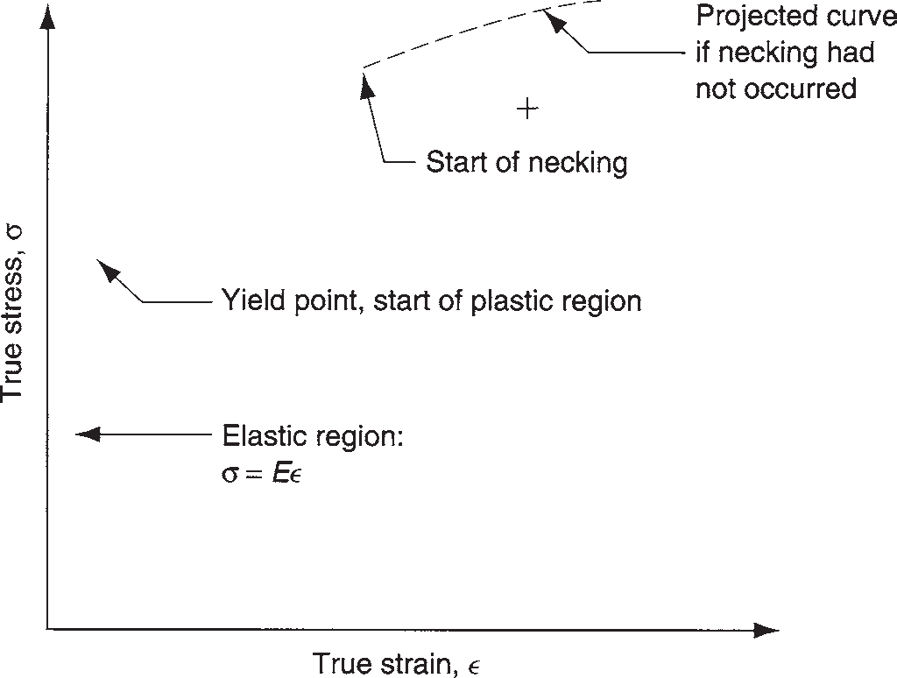

**FIGURE 3.4** True

stress–strain curve for the previous engineering stress– strain plot in Figure 3.3.

previous curve, a downturn finally occurs as a result of necking. A dashed line is used in the figure to indicate the projected continuation of the true stress–strain plot if necking had not occurred.

As strain becomes significant in the plastic region, the values of true strain and engineering strain diverge. True strain can be related to the corresponding engineer- ing strain by

*e* = ln(1 + *e*) (3.8)

Similarly, true stress and engineering stress can be related by the expression

*s* = *s* (1 + *e*) (3.9)

In Figure 3.4, note that stress increases continuously in the plastic region until necking begins. When this happened in the engineering stress–strain curve, its sig- nificance was lost because an admittedly erroneous area value was used to calculate stress. Now when the true stress also increases, it cannot be dismissed so lightly. What it means is that the metal is becoming stronger as strain increases. This is the property called ***strain hardening*** that was mentioned in the previous chapter in the discussion of metallic crystal structures, and it is a property that most metals exhibit to a greater or lesser degree.

|  |  |
| --- | --- |
| Example 3.2 True stress and strain | For the data given in Example 3.1, determine (a) true stress and (b) true strain at the maximum load of 65,000 N.  **Solution:** (a) True stress is defined as the load divided by the instantaneous area. To find the instantaneous area, we assume uniform elongation prior to necking. Thus, *AL* = *AoLo*, and *A* = *AoLo*/*L* = 200(50)/57.7 = 173.3 mm2.  *s* = *F*/*A* = 65,000/173.3 = **375 MPa**  (b) By Equation (3.7), true strain *e* = ln(*L*/*Lo*) = ln(57.7/50) =  ln(1.154) = **0.143**.  **Check:** Use Equations (3.8) and (3.9) to check these values: Using Equation (3.8) and the value of *e* obtained in Example 3.1,  *e* = ln(1 + 0.154) = 0.143.  Using Equation (3.9) and the value of *TS* obtained in Example 3.1,  *s* = 325(1 + 0.154) = 375 MPa.  **Comment:** Note that true stress is always greater than engineering stress, and true strain is always less than engineering strain. |
|  |

Strain hardening, or ***work hardening*** as it is often called, is an important factor in certain manufacturing processes, particularly metal forming. Accordingly, it is worth- while to examine the behavior of a metal as it is affected by this property. If the portion of the true stress–strain curve representing the plastic region were plotted on a log–log scale, the result would be a linear relationship, as shown in Figure 3.5.

**FIGURE 3.5** True stress–strain curve plotted on log–log scale.

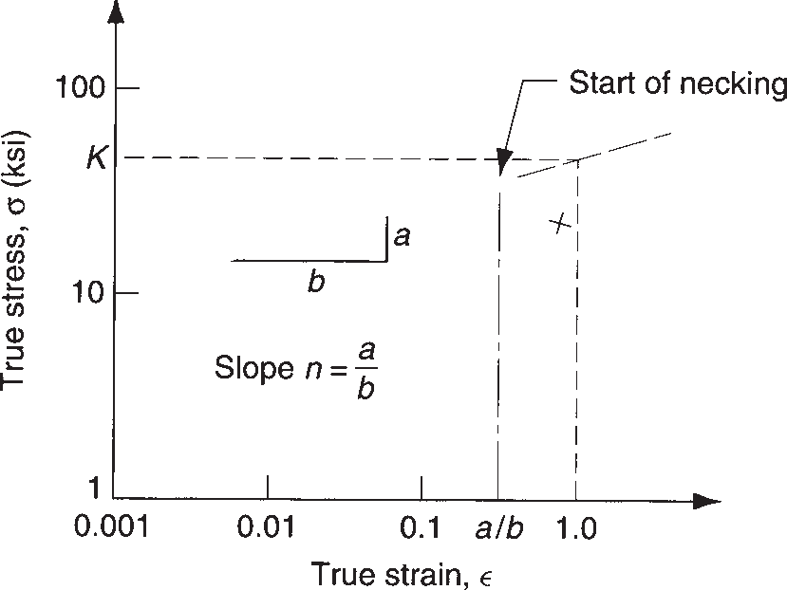

Because it is a straight line in this transformation of the data, the relationship between true stress and true strain in the plastic region can be expressed as

*s* = *Ken* (3.10)

This equation is called the ***flow curve***, and it provides a good approximation of the behavior of metals in the plastic region, including their capacity for strain hardening. The constant *K* is called the ***strength coefficient***, MPa (lb/in2), and it equals the value of true stress at a true strain value equal to one. The parameter *n* is called the ***strain hardening exponent***, and it is the slope of the line in Figure 3.5. Its value is directly related to a metal’s tendency to work harden. Typical values of *K* and *n* for selected metals are given in Table 3.4.

**TABLE** • **3.4** Typical values of strength coefficient *K* and strain hardening exponent n for selected metals.

|  |  |  |  |  |  |  |  |  |
| --- | --- | --- | --- | --- | --- | --- | --- | --- |
|  |  | **Strength Coefficient, *K*** | | **Strain Hardening** |  | **Strength Coefficient, *K*** | | **Strain Hardening** |
| **Material** | **MPa lb/in2** | | **Exponent, *n*** | **Material** | **MPa lb/in2** | | **Exponent, *n*** |
| Aluminum, pure, annealed | 175 | 25,000 | 0.20 | Steel, low C, annealeda | 500 | 75,000 | 0.25 |
| Aluminum alloy, annealeda | 240 | 35,000 | 0.15 | Steel, high C, annealeda | 850 | 125,000 | 0.15 |
| Aluminum alloy, heat treated | 400 | 60,000 | 0.10 | Steel, alloy, annealeda | 700 | 100,000 | 0.15 |
| Copper, pure, annealed | 300 | 45,000 | 0.50 | Steel, stainless, austenitic, annealed | 1200 | 175,000 | 0.40 |
| Copper alloy: brassa | 700 | 100,000 | 0.35 |  |  | |  |

Compiled from [9], [10], [11], and other sources.

aValues of *K* and *n* vary according to composition, heat treatment, and work hardening.

|  |  |
| --- | --- |
| Example 3.3 Flow curve | For the data given in Example 3.1, determine the strength coefficient and strain hardening exponent in the flow curve equation: *s* = *Ken*. |
| parameters | **Solution:** We have two points on the flow curve from which the flow curve parameters can be determined: (1) at the yield point and (2) at the maximum |
|  |
| load. |
| (1) At the yield point, engineering stress is very close to the value of true stress. |
| Thus, from Example 3.1, *s* = *Y* = 160 MPa. True strain is calculated using the gage |
| length at yielding and adjusting for the 0.2% offset: *e* = ln(50.2/50 - .002) = |
| 0.001998. The corresponding flow curve equation is 160 = *K*(0.001998)*n*. |
| (2) At the maximum load, the values of true stress and true strain are |
| available from the solution of Example 3.2: *e* = 0.143 and *s* = 375 MPa. |
| The corresponding flow curve equation is 375 = *K*(0.143)*n*. |
| Solving for *n* and *K*, |
| (1) *K* = 160/(0.001998)*n* and (2) *K* = 375/(0.143)*n* |
| 160/(0.001998)*n* = 375/(0.143)*n* |
| ln(160) - *n* ln(0.001998) = ln(375) - *n* ln(0.143) |
| 5.0752 - (-6.2156)*n* = 5.9269 - (-1.9449)*n* |
| 5.0752 + 6.2156*n* = 5.9269 + 1.9449*n* |
| (6.2156 - 1.9449)*n* = 5.9269 - 5.0752 |
| 4.2707*n* = 0.8517 *n* = 0.1994 |
| Substituting back into (1): *K* = 160/(0.001998)0.1994 = 552.7. |
| **Check:** Using (2): *K* = 375/(0.143)0.1994 = 552.7. |
| The flow curve equation is *s* = **552.7***e***0.1994**. |

Necking in a tensile test and in metal forming operations that stretch the work part is closely related to strain hardening. As the test specimen is elongated during the initial part of the test (before necking begins), uniform straining occurs through- out the length because if any element in the specimen becomes strained more than the surrounding metal, its strength increases by work hardening, thus making it more resistant to additional strain until the surrounding metal has been strained an equal amount. Finally, the strain becomes so large that uniform straining cannot be sustained. A weak point in the length develops (from buildup of dislocations at grain boundaries, impurities in the metal, or other factors), and necking is initiated, leading to failure. Empirical evidence reveals that necking begins for a particular metal when the true strain reaches a value equal to the strain-hardening exponent *n*. Therefore, a higher *n* value means that the metal can be strained further before the onset of necking during tensile loading.

**Types of Stress–Strain Relationships** Much information about elastic–plastic behavior is provided by the true stress–strain curve. As indicated, Hooke’s law (*s* = *Ee*) governs the metal’s behavior in the elastic region, and the flow curve

**FIGURE 3.6** Three

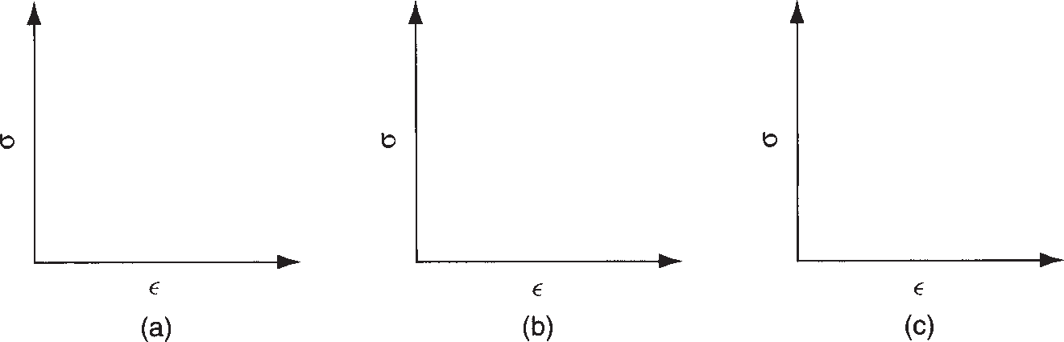

categories of stress– strain relationship:

* 1. perfectly elastic,
  2. elastic and perfectly plastic, and (c) elastic and strain hardening.

(*s* = *Ken*) determines the behavior in the plastic region. Three basic forms of stress– strain relationship describe the behavior of nearly all types of solid materi- als, shown in Figure 3.6:

* + 1. ***Perfectly elastic***. The behavior of this material is defined completely by its stiff- ness, indicated by the modulus of elasticity *E*. It fractures rather than yielding to plastic flow. Brittle materials such as ceramics, many cast irons, and thermo- setting polymers possess stress–strain curves that fall into this category. These materials are not good candidates for forming operations.
    2. ***Elastic and perfectly plastic***. This material has a stiffness defined by *E*. Once the yield strength *Y* is reached, the material deforms plastically at the same stress level. The flow curve is given by *K* = *Y* and *n* = 0. Metals behave in this fashion when they have been heated to sufficiently high temperatures that they recrystallize rather than strain harden during deformation. Lead exhibits this behavior at room temperature because room temperature is above the recrys- tallization point for lead.
    3. ***Elastic and strain hardening***. This material obeys Hooke’s law in the elastic region. It begins to flow at its yield strength *Y*. Continued deformation requires an ever-increasing stress, given by a flow curve whose strength coefficient *K* is greater than *Y* and whose strain-hardening exponent *n* is greater than zero. The flow curve is generally represented as a linear function on a natural logarithmic plot. Most ductile metals behave this way when cold worked.

Manufacturing processes that deform materials through the application of tensile stresses include wire and bar drawing (Section 18.6) and stretch forming (Section 19.6.1).

## COMPRESSION PROPERTIES

A compression test applies a load that squeezes a cylindrical specimen between two platens, as illustrated in Figure 3.7. As the specimen is compressed, its height is re- duced and its cross-sectional area is increased. Engineering stress is defined as

*s* =  *F*

*Ao*

(3.11)

where *Ao* = original area of the specimen. This is the same definition of engineering stress used in the tensile test. The engineering strain is defined as

*e* = *h* - *ho*

*h o*

(3.12)

**FIGURE 3.7**

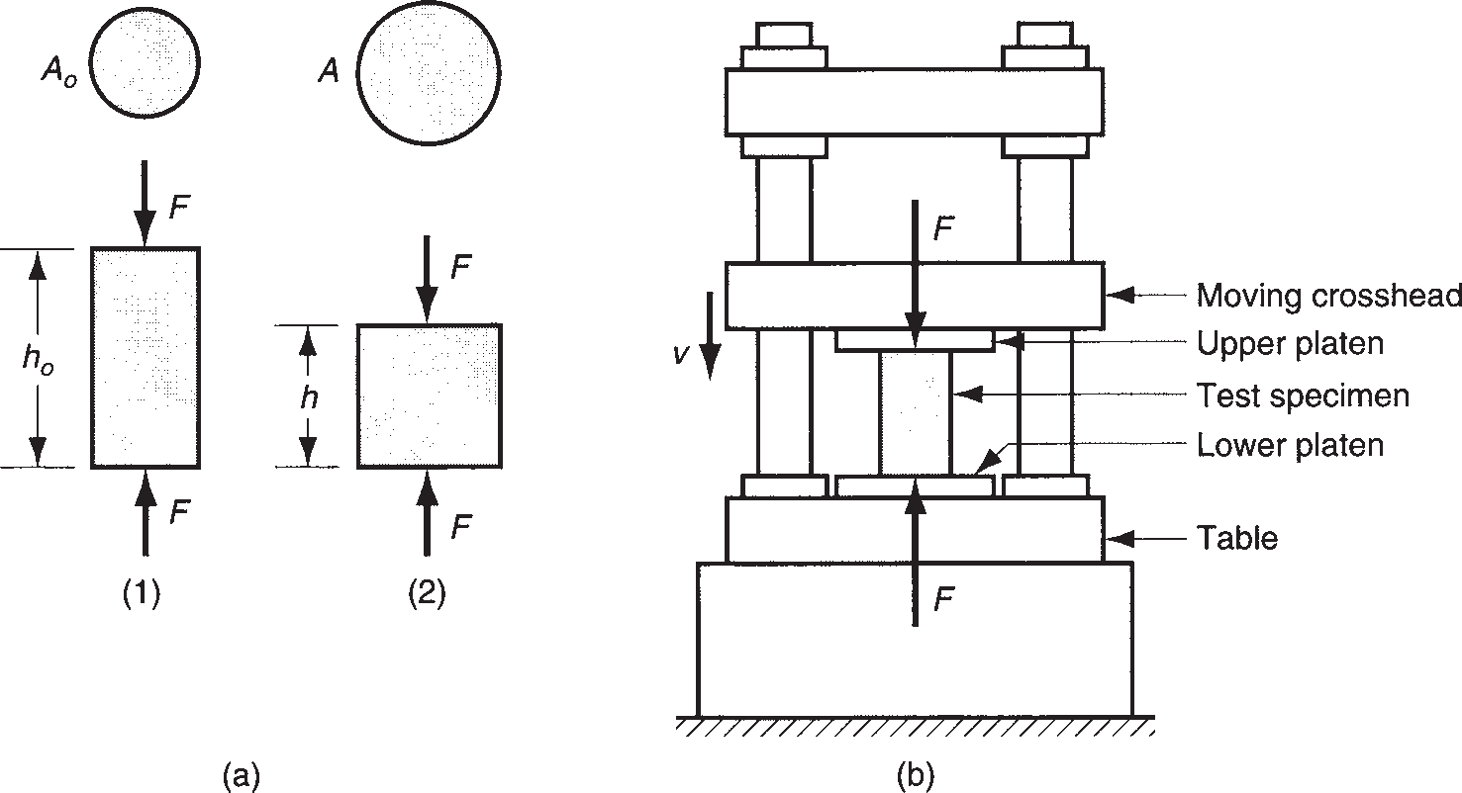

Compression test:

1. compression force applied to test piece in (1), and (2) resulting change in height; and
2. setup for the test, with size of test speci- men exaggerated.

where *h* = height of the specimen at a particular moment into the test, mm (in); and *ho*

= starting height, mm (in). Because the height is decreased during compression, the value of *e* will be negative. The negative sign is usually ignored when expressing values of compression strain.

When engineering stress is plotted against engineering strain in a compression test, the results appear as in Figure 3.8. The curve is divided into elastic and plas- tic regions, as before, but the shape of the plastic portion of the curve is different from its tensile test complement. Because compression causes the cross section to increase (rather than decrease as in the tensile test), the load increases more rapidly than previously. This results in a higher value of calculated engineering stress.

Something else happens in the compression test that contributes to the increase in stress. As the cylindrical specimen is squeezed, friction at the surfaces in contact with the platens tends to prevent the ends of the cylinder from spreading. Additional

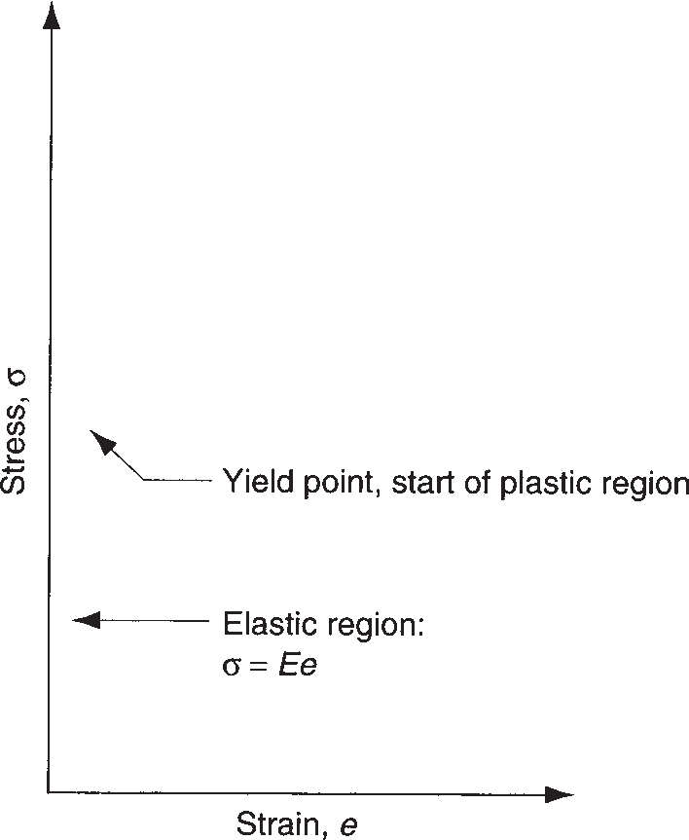

*s* = *Ee*

**FIGURE 3.8** Typical engineering stress– strain curve for a compression test.

Stress, *s*

**FIGURE 3.9** Barreling effect in a compression test:

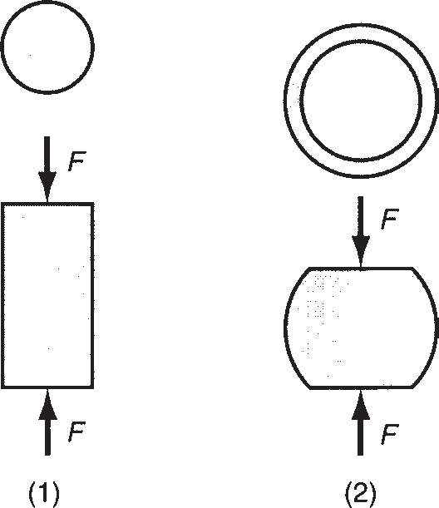

* 1. start of test; and (2) after considerable compression has occurred.

energy is consumed by this friction during the test, and this results in a higher applied force. It also shows up as an increase in the computed engineering stress. Hence, ow- ing to the increase in cross-sectional area and friction between the specimen and the platens, the characteristic engineering stress–strain curve in a compression test is obtained, as shown in the figure.

Another consequence of the friction between the surfaces is that the material near the middle of the specimen is permitted to increase in area much more than at the ends. This results in the characteristic ***barreling*** of the specimen, as seen in Figure 3.9.

Although differences exist between the engineering stress–strain curves in ten- sion and compression, when the respective data are plotted as true stress–strain, the relationships are nearly identical (for almost all materials). Because tensile test results are more abundant in the literature, values of the flow curve parameters (*K* and *n*) can be derived from tensile test data and applied with equal validity to a compression operation. What must be done in using the tensile test results for a com- pression operation is to ignore the effect of necking, a phenomenon that is peculiar to straining induced by tensile stresses. In compression, there is no corresponding collapse of the work. In previous plots of tensile stress–strain curves, the data were extended beyond the point of necking by means of the dashed lines. The dashed lines better represent the behavior of the material in compression than the actual tensile test data.

Compression operations in metal forming are much more common than stretch- ing operations. Important compression processes in industry include rolling, forging, and extrusion (Chapter 18).

## BENDING AND TESTING OF BRITTLE MATERIALS

Bending operations are used to form metal plates and sheets. As shown in Fig- ure 3.10, the process of bending a rectangular cross section subjects the material to tensile stresses (and strains) in the outer half of the bent section and compressive stresses (and strains) in the inner half. If the material does not fracture, it becomes permanently (plastically) bent as shown in (3) of Figure 3.10.

Hard, brittle materials (e.g., ceramics), which possess elasticity but little or no plasticity, are often tested by a method that subjects the specimen to a bending

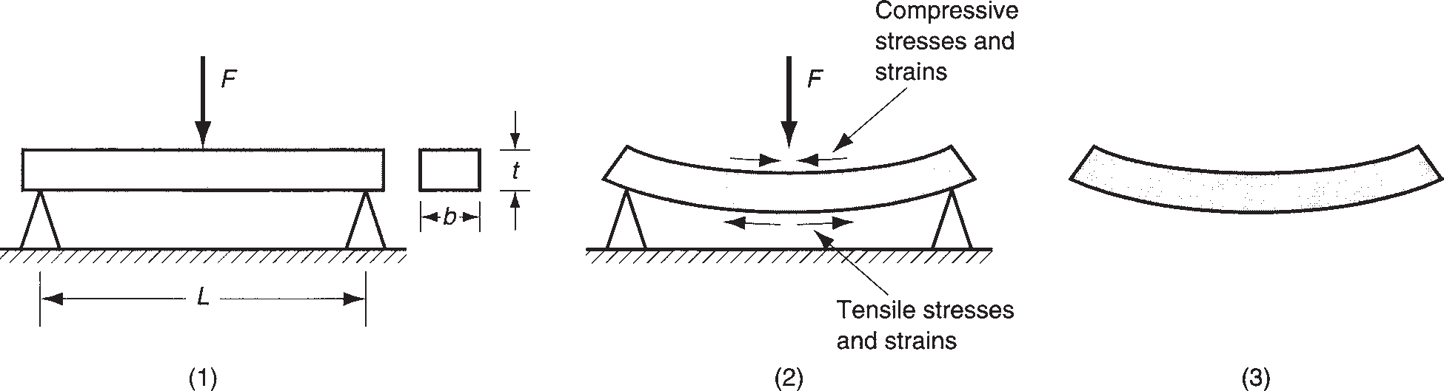

**FIGURE 3.10** Bending of a rectangular cross section results in both tensile and compressive stresses in the material: (1) initial loading; (2) highly stressed and strained specimen; and (3) bent part.

load. These materials do not respond well to traditional tensile testing because of problems in preparing the test specimens and possible misalignment of the press jaws that hold the specimen. The ***bending test*** (also known as the ***flexure test***) is used to test the strength of these materials, using a setup illustrated in the first diagram in Figure 3.10. In this procedure, a specimen of rectangular cross section is positioned between two supports, and a load is applied at its center. In this con- figuration, the test is called a three-point bending test. A four-point configuration is also sometimes used. These brittle materials do not flex to the exaggerated ex- tent shown in Figure 3.10; instead they deform elastically until immediately be- fore fracture. Failure usually occurs because the ultimate tensile strength of the outer fibers of the specimen has been exceeded. This results in ***cleavage***, a failure mode associated with ceramics and metals operating at low service temperatures, in which separation rather than slip occurs along certain crystallographic planes. The strength value derived from this test is called the ***transverse rupture strength***, calculated from the formula

*TRS* = 1.5*FL* (3.13)

*bt*2

where *TRS* = transverse rupture strength, MPa (lb/in2); *F* = applied load at fracture, N (lb); *L* = length of the specimen between supports, mm (in); and *b* and *t* are the dimensions of the cross section of the specimen as shown in the figure, mm (in).

The flexure test is also used for certain nonbrittle materials such as thermoplastic polymers. In this case, because the material is likely to deform rather than fracture, TRS cannot be determined based on failure of the specimen. Instead, either of two measures is used: (1) the load recorded at a given level of deflection, or (2) the de- flection observed at a given load.

## SHEAR PROPERTIES

Shear involves application of stresses in opposite directions on either side of a thin element to deflect it as shown in Figure 3.11. The shear stress is defined as

*t* =  *F* (3.14)

*A*

**FIGURE 3.11** Shear

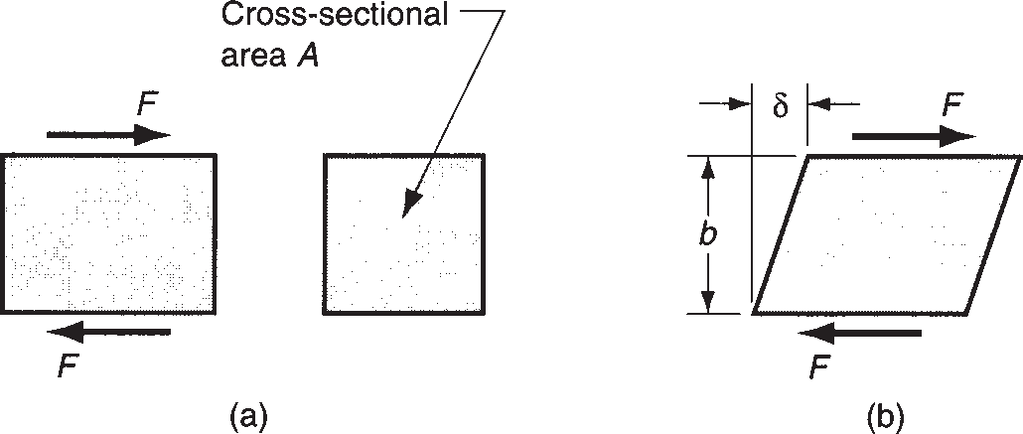

* + - 1. stress and (b) strain.

where *t* = shear stress, lb/in2 (MPa); *F* = applied force, N (lb); and *A* = area over which the force is applied, in2 (mm2). Shear strain can be defined as

*g* =  *d*

*b*

(3.15)

where *g* = shear strain, mm/mm (in/in); *d* = the deflection of the element, mm (in); and *b* = the orthogonal distance over which deflection occurs, mm (in).

Shear stress and strain are commonly tested in a ***torsion test***, in which a thin- walled tubular specimen is subjected to a torque as shown in Figure 3.12. As torque is increased, the tube deflects by twisting, which is a shear strain for this geometry.

The shear stress can be determined in the test by the equation

*t* =  *T*

2*pR*2*t*

(3.16)

where *T* = applied torque, N-mm (lb-in); *R* = radius of the tube measured to the neutral axis of the wall, mm (in); and *t* = wall thickness, mm (in). The shear strain can be determined by measuring the amount of angular deflection of the tube, convert- ing this into a distance deflected, and dividing by the gauge length *L*. Reducing this to a simple expression,

*g* = *Ra*

*L*

where a. = the angular deflection (radians).

(3.17)

A typical shear stress–strain curve is shown in Figure 3.13. In the elastic region, the relationship is defined by

*t* = *Gg* (3.18)

**FIGURE 3.12** Torsion test setup.

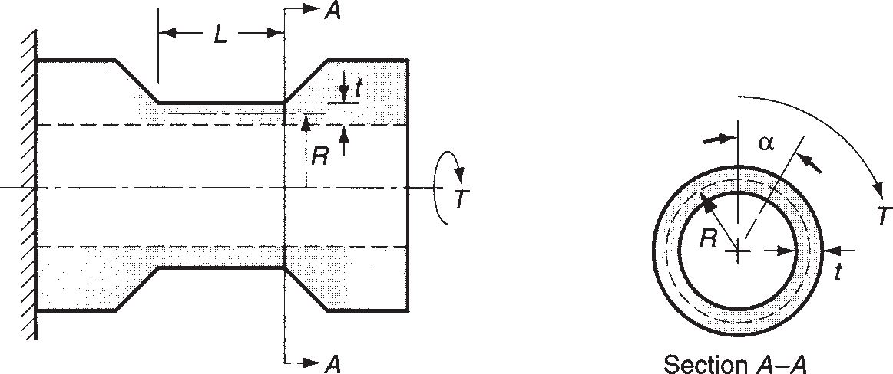

**FIGURE 3.13** Typical shear stress– strain curve from a torsion test.

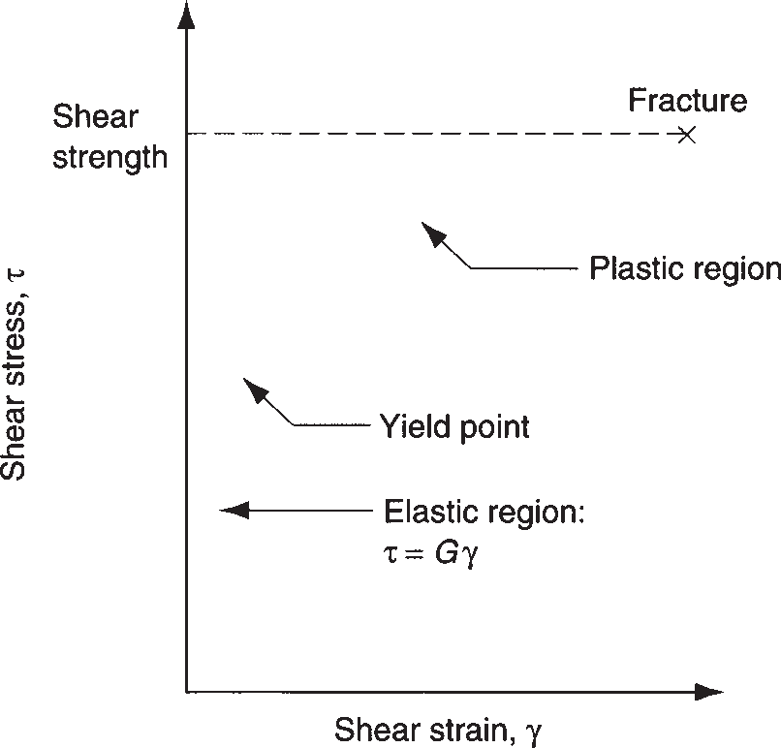

where *G* = the ***shear modulus***, or ***shear modulus of elasticity***, MPa (lb/in2). For most materials, the shear modulus can be approximated by *G* = 0.4*E*, where *E* is the conventional elastic modulus.

In the plastic region of the shear stress–strain curve, the material strain hardens to cause the applied torque to continue to increase until fracture finally occurs. The relationship in this region is similar to the flow curve. The shear stress at fracture can be calculated and this is used as the ***shear strength*** *S* of the material. Shear strength can be estimated from tensile strength data by the approximation: *S*

= 0.7(*TS*).

Because the cross-sectional area of the test specimen in the torsion test does not change as it does in the tensile and compression tests, the engineering stress–strain curve for shear derived from the torsion test is virtually the same as the true stress– strain curve.

Shear processes are common in industry. Shearing action is used to cut sheet metal in blanking, punching, and other cutting operations (Section 19.1). In machining, the material is removed by the mechanism of shear deformation (Section 20.2).

# Hardness

**3.2**

The hardness of a material is defined as its resistance to permanent indentation. Good hardness generally means that the material is resistant to scratching and wear. For many engineering applications, including most of the tooling used in manufac- turing, scratch and wear resistance are important characteristics. As the reader shall see later in this section, there is a strong correlation between hardness and strength.

## HARDNESS TESTS

Hardness tests are commonly used for assessing material properties because they are quick and convenient. However, a variety of testing methods are appropriate because of differences in hardness among different materials. The best-known hard- ness tests are Brinell and Rockwell.

**Brinell Hardness Test** The Brinell hardness test is widely used for testing metals and nonmetals of low- to medium hardness. It is named after the Swedish engineer who developed it around 1900. In the test, a hardened steel (or cemented carbide) ball of 10-mm diameter is pressed into the surface of a specimen using a load of 500, 1500, or 3000 kg. The load is then divided into the indentation area to obtain the Brinell Hardness Number (BHN). In equation form,

*HB* = 2*F*

*pDb*(*Db* - )*D*2 - *D*2 )

*b* *i*

(3.19)

where *HB* = Brinell Hardness Number (BHN); *F* = indentation load, kg; *Db* =

diameter of the ball, mm; and *Di* = diameter of the indentation on the surface, mm.

These dimensions are indicated in Figure 3.14(a). The resulting BHN has units of kg/mm2, but the units are usually omitted in expressing the number. For harder materials (above 500 BHN), the cemented carbide ball is used because the steel ball experiences elastic deformation that compromises the accuracy of the reading. Also, higher loads (1500 and 3000 kg) are typically used for harder materials. Because of differences in results under different loads, it is considered good practice to indicate the load used in the test when reporting *HB* readings.

**Rockwell Hardness Test** This is another widely used test, named after the met- allurgist who developed it in the early 1920s. It is convenient to use, and several enhancements over the years have made the test adaptable to a variety of materials. In the Rockwell Hardness Test, a cone-shaped indenter or small-diameter ball, with diameter = 1.6 or 3.2 mm (1/16 or 1/8 in) is pressed into the specimen using a minor load of 10 kg, thus seating the indenter in the material. Then, a major load of 150 kg (or other value) is applied, causing the indenter to penetrate into the

**FIGURE 3.14**

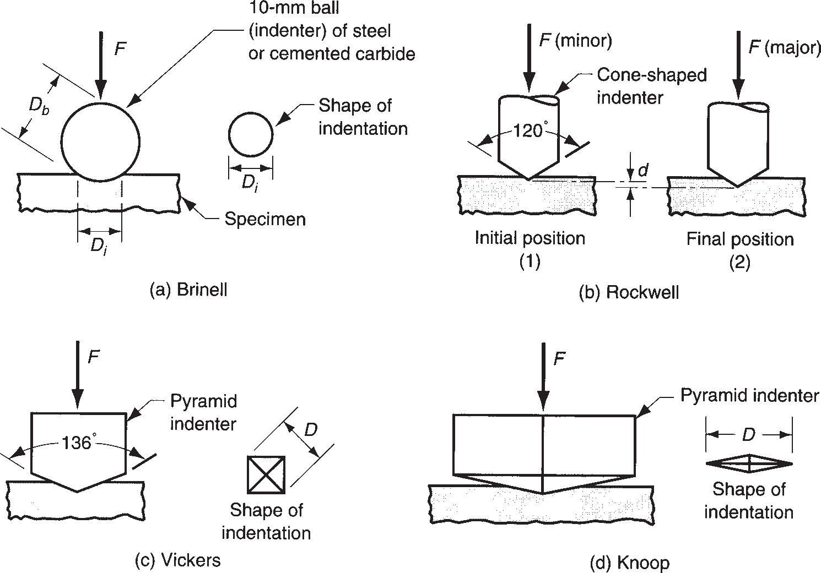

Hardness testing methods: (a) Brinell;

* + - 1. Rockwell: (1) initial minor load and
  1. major load,
     + 1. Vickers, and
       2. Knoop.

|  |  |  |  |  |  |
| --- | --- | --- | --- | --- | --- |
|  | **TABLE** • **3.5** Common Rockwell hardness scales. | | | | |
|  | **Rockwell Scale** | **Hardness Symbol** | **Indenter** | **Load (kg)** | **Typical Materials Tested** |
| A B C | HRA HRB HRC | Cone  1.6 mm ball Cone | 60  100  150 | Carbides, ceramics Nonferrous metals Ferrous metals, tool steels |

specimen a certain distance beyond its initial position. This additional penetration distance *d* is converted into a Rockwell hardness reading by the testing machine. The sequence is depicted in Figure 3.14(b). Differences in load and indenter ge- ometry provide various Rockwell scales for different materials. The most common scales are indicated in Table 3.5.



**Vickers Hardness Test** This test, also developed in the early 1920s, uses a pyra- mid-shaped indenter made of diamond. It is based on the principle that impressions made by this indenter are geometrically similar regardless of load. Accordingly, loads of various size are applied, depending on the hardness of the material to be measured. The Vickers Hardness (*HV*) is then determined from the formula

*HV* = 1.854 *F*

*D*2

(3.20)

where *F* = applied load, kg, and *D* = the diagonal of the impression made by the indenter, mm, as indicated in Figure 3.14(c). The Vickers test can be used for all met- als and has one of the widest scales among hardness tests.

**Knoop Hardness Test** The Knoop test, developed in 1939, uses a pyramid-shaped diamond indenter, but the pyramid has a length-to-width ratio of about 7:1, as indi- cated in Figure 3.14(d), and the applied loads are generally lighter than in the Vick- ers test. It is a microhardness test, meaning that it is suitable for measuring small, thin specimens or hard materials that might fracture if a heavier load were applied. The indenter shape facilitates reading of the impression under the lighter loads used in this test. The Knoop hardness value (*HK*) is determined according to the formula

*HK* = 14.2  *F*

*D*2

(3.21)

where *F* = load, kg; and *D* = the long diagonal of the indentor, mm. Because the impression made in this test is generally very small, considerable care must be taken in preparing the surface to be measured.

**Scleroscope** The previous tests base their hardness measurements either on the ratio of applied load divided by the resulting impression area (Brinell, Vickers, and Knoop) or by the depth of the impression (Rockwell). The Scleroscope is an in- strument that measures the rebound height of a “hammer” dropped from a certain distance above the surface of the material to be tested. The hammer consists of a weight with diamond indenter attached to it. The Scleroscope therefore measures the mechanical energy absorbed by the material when the indenter strikes the sur- face. The energy absorbed gives an indication of resistance to penetration, which is consistent with the definition of hardness. If more energy is absorbed, the rebound

will be less, meaning a softer material. If less energy is absorbed, the rebound will be higher—thus a harder material. The primary use of the Scleroscope seems to be in measuring the hardness of large parts of steel and other ferrous metals.

**Durometer** The previous tests are all based on resistance to permanent or plastic deformation (indentation). The durometer is a device that measures the elastic de- formation of rubber and similar flexible materials by pressing an indenter into the surface of the object. The resistance to penetration is an indication of hardness, as the term is applied to these types of materials.

## HARDNESS OF VARIOUS MATERIALS

This section compares the hardness values of some common materials in the three engineering material classes: metals, ceramics, and polymers.

**Metals** The Brinell and Rockwell hardness tests were developed at a time when metals were the principal engineering materials. A significant amount of data has been collected using these tests on metals. Table 3.6 lists hardness values for selected metals. For most metals, hardness is closely related to strength. Because the method of testing for hardness is usually based on resistance to indentation, which is a form of compression, one would expect a good correlation between hardness and strength properties determined in a compression test. However, strength properties in a com- pression test are nearly the same as those from a tension test, after allowances for changes in cross-sectional area of the respective test specimens; so the correlation

with tensile properties should also be good.

Brinell hardness (*HB*) exhibits a close correlation with the ultimate tensile strength *TS* of steels, leading to the relationship [9], [15]:

*TS* = *Kh*(*HB*) (3.22)

|  |  |  |  |  |  |  |
| --- | --- | --- | --- | --- | --- | --- |
|  | **TABLE** • **3.6** Typical hardness of selected metals. | | | | | |
|  | **Metal** | **Brinell Hardness**, **HB** | **Rockwell Hardness**, **HRa** | **Metal** | **Brinell Hardness**, **HB** | **Rockwell Hardness**, **HRa** |
| Aluminum, annealed | 20 |  | Magnesium alloys, hardenedb | 70 | 35B |
| Aluminum, cold worked | 35 |  | Nickel, annealed | 75 | 40B |
| Aluminum alloys, annealedb | 40 |  | Steel, low C, hot rolledb | 100 | 60B |
| Aluminum alloys, hardenedb | 90 | 52B | Steel, high C, hot rolledb | 200 | 95B, 15C |
| Aluminum alloys, castb | 80 | 44B | Steel, alloy, annealedb | 175 | 90B, 10C |
| Cast iron, gray, as castb | 175 | 10C | Steel, alloy, heat treatedb | 300 | 33C |
| Copper, annealed | 45 |  | Steel, stainless, austeniticb | 150 | 85B |
| Copper alloy: brass, annealed | 100 | 60B | Titanium, nearly pure | 200 | 95B |
| Lead | 4 |  | Zinc | 30 |  |

Compiled from [10], [11], [16], and other sources.

aHR values are given in the B or C scale as indicated by the letter designation. Missing values indicate that the hardness is too low for Rockwell scales.

bHB values given are typical. Hardness values will vary according to composition, heat treatment, and degree of work hardening.

|  |  |  |  |  |  |  |
| --- | --- | --- | --- | --- | --- | --- |
|  |  | **Vickers Knoop** | |  | **Vickers Knoop** | |
|  | **Hardness**, **Hardness**, | |  | **Hardness**, **Hardness**, | |
| **Material** | **HV HK** | | **Material** | **HV HK** | |
| Hardened tool steela | 800 | 850 | Titanium nitride, TiN | 3000 | 2300 |
| Cemented carbide (WC - Co)a | 2000 | 1400 | Titanium carbide, TiC | 3200 | 2500 |
| Alumina, Al2O3 | 2200 | 1500 | Cubic boron nitride, BN | 6000 | 4000 |
| Tungsten carbide, WC | 2600 | 1900 | Diamond, sintered polycrystal | 7000 | 5000 |
| Silicon carbide, SiC | 2600 | 1900 | Diamond, natural | 10,000 | 8000 |

Compiled from [14], [16], and other sources.



**TABLE** • **3.7** Hardness of selected ceramics and other hard materials, arranged in ascending order of hardness.

aHardened tool steel and cemented carbide are the two materials commonly used in the Brinell hardness test.

|  |  |  |  |  |
| --- | --- | --- | --- | --- |
|  | **Polymer** | **Brinell Hardness**, **HB** | **Polymer** | **Brinell Hardness**, **HB** |
| Nylon | 12 | Polypropylene | 7 |
| Phenol formaldehyde | 50 | Polystyrene | 20 |
| Polyethylene, low density | 2 | Polyvinyl-chloride | 10 |
| Polyethylene, high density | 4 |  |  |

Compiled from [5], [8], and other sources.



**TABLE** • **3.8** Hardness of selected polymers.

where *Kh* is a constant of proportionality. If *TS* is expressed in MPa, then *Kh* = 3.45; and if *TS* is in lb/in2, then *Kh* = 500.

**Ceramics** The Brinell hardness test is not appropriate for ceramics because the materials being tested are often harder than the indenter ball. The Vickers and Knoop hardness tests are used to test these hard materials. Table 3.7 lists hardness values for several ceramics and hard materials. For comparison, the Rockwell C hardness for hardened tool steel is 65 HRC. The HRC scale does not extend high enough to be used for the harder materials.

**Polymers** Polymers have the lowest hardness among the three types of engineer- ing materials. Table 3.8 lists several of the polymers on the Brinell hardness scale, al- though this testing method is not normally used for these materials. It does, however, allow comparison with the hardness of metals.

# Effect of Temperature on Properties

**3.3**

Temperature has a significant effect on nearly all properties of a material. It is im- portant for the designer to know the material properties at the operating tempera- tures of the product when in service. It is also important to know how temperature affects mechanical properties in manufacturing. At elevated temperatures, materials are lower in strength and higher in ductility. The general relationships for metals are depicted in Figure 3.15. Thus, most metals can be formed more easily at elevated temperatures than when they are cold.

**FIGURE 3.15** General effect of temperature on strength and ductility.

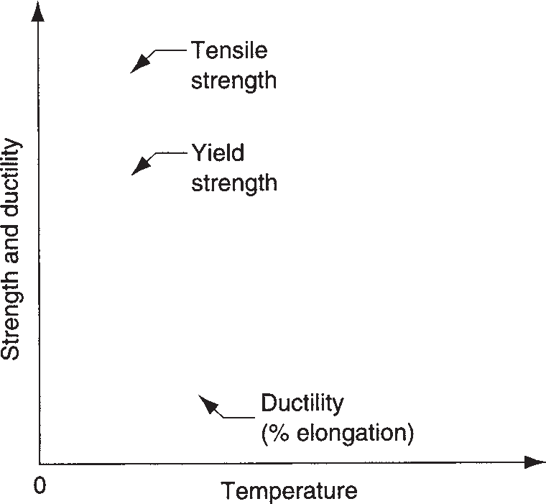

**Hot Hardness** A property often used to characterize strength and hardness at el- evated temperatures is hot hardness. ***Hot hardness*** is simply the ability of a material to retain hardness at elevated temperatures; it is usually presented as either a listing of hardness values at different temperatures or as a plot of hardness versus tempera- ture, as in Figure 3.16. Steels can be alloyed to achieve significant improvements in hot hardness, as shown in the figure. Ceramics exhibit superior properties at elevated temperatures compared with other materials. They are often selected for high tem- perature applications, such as turbine parts, cutting tools, and refractory applications.

Good hot hardness is also desirable in the tooling materials used in many manu- facturing operations. Significant amounts of heat energy are generated in most met- alworking processes, and the tools must be capable of withstanding the high tem- peratures involved.

**Recrystallization Temperature** Most metals behave at room temperature ac- cording to the flow curve in the plastic region. As the metal is strained, it increases in strength because of strain hardening (the strain-hardening exponent *n* > 0). How- ever, if the metal is heated to a sufficiently elevated temperature and then deformed,

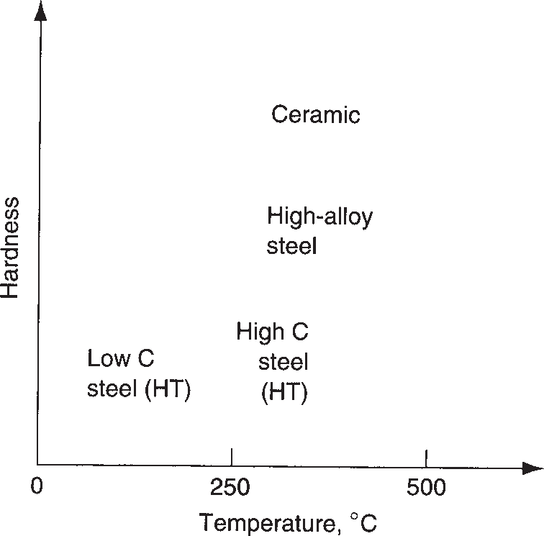

**FIGURE 3.16** Hot hardness—typical hardness as a function of temperature for several materials.

strain hardening does not occur. Instead, new grains are formed that are free of strain, and the metal behaves as a perfectly plastic material, that is, with a strain- hardening exponent *n* = 0. The formation of new strain-free grains is a process called ***recrystallization***, and the temperature at which it occurs is about one-half the melting point (0.5 *Tm*), as measured on an absolute scale (R or K). This is called the ***recrystallization temperature***. Recrystallization takes time. The recrystallization temperature for a particular metal is usually specified as the temperature at which complete formation of new grains requires about 1 hour.

Recrystallization is a temperature-dependent characteristic of metals that can be exploited in manufacturing. By heating the metal to the recrystallization tempera- ture before deformation, the amount of straining that the metal can endure is sub- stantially increased, and the forces and power required to carry out the process are significantly reduced. Forming metals at temperatures above the recrystallization temperature is called ***hot working*** (Section 17.3).

# Fluid Properties

**3.4**

Fluids behave quite differently than solids. A fluid flows; it takes the shape of the container that holds it. A solid does not flow; it possesses a geometric form that is independent of its surroundings. Fluids include liquids and gases; the interest in this section is on the former. Many manufacturing processes are accomplished on mate- rials that have been converted from solid to liquid state by heating. Metals are cast in the molten state; glass is formed in a heated and highly fluid state; and polymers are almost always shaped as thick fluids.

**Viscosity** Although flow is a defining characteristic of fluids, the tendency to flow varies for different fluids. Viscosity is the property that determines fluid flow. Roughly, ***viscosity*** can be defined as the resistance to flow that is characteristic of a fluid. It is a measure of the internal friction that arises when velocity gradients are present in the fluid—the more viscous the fluid is, the higher the internal friction and the greater the resistance to flow. The reciprocal of viscosity is ***fluidity***—the ease with which a fluid flows.

Viscosity is defined more precisely with respect to the setup in Figure 3.17, in which two parallel plates are separated by a distance *d*. One of the plates is station- ary while the other is moving at a velocity *v*, and the space between the plates is occupied by a fluid. Orienting these parameters relative to an axis system, *d* is in the *y*-axis direction and *v* is in the *x*-axis direction. The motion of the upper plate is

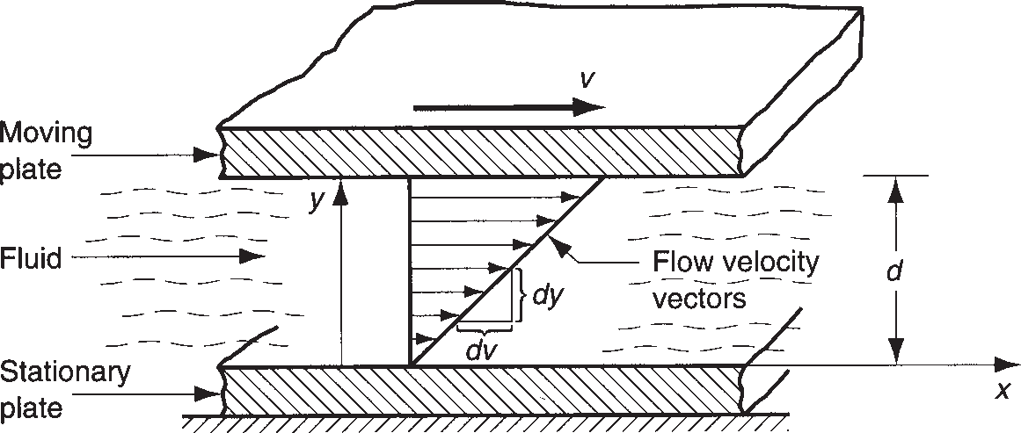

**FIGURE 3.17** Fluid

flow between two parallel plates, one stationary and the other moving at velocity *v.*

resisted by force *F* that results from the shear viscous action of the fluid. This force can be reduced to a shear stress by dividing *F* by the plate area *A*:

*t* =  *F* (3.23)

*A*

where *t* = shear stress, N/m2or Pa (lb/in2). This shear stress is related to the rate of shear, which is defined as the change in velocity *dv* relative to *dy*. That is,

*? dv dy*

*g* =

(3.24)

where *g?* = shear rate, 1/s; *dv* = incremental change in velocity, m/s (in/sec); and *dy* = incremental change in distance y, m (in). The shear viscosity is the fluid property that defines the relationship between *F/A* and *dv*/*dy*; that is,

*F* = *h dv* or *t* = *hg?* (3.25)

*A dy*

where *h* = a constant of proportionality called the coefficient of viscosity, Pa-s (lb-sec/in2). Rearranging Equation (3.25), the coefficient of viscosity can be ex- pressed as follows:

*h* = *t*

*?*

*g*

(3.26)

Thus, the viscosity of a fluid can be defined as the ratio of shear stress to shear rate during flow, where shear stress is the frictional force exerted by the fluid per unit area, and shear rate is the velocity gradient perpendicular to the flow direction. The viscous characteristics of fluids defined by Equation (3.26) were first stated by New- ton. He observed that viscosity was a constant property of a given fluid, and such a fluid is referred to as a ***Newtonian fluid***.

The units of coefficient of viscosity require explanation. In the International Sys- tem of units (SI), because shear stress is expressed in N/m2 or Pascals and shear rate in 1/s, it follows that *h* has units of N-s/m2 or Pascal-seconds, abbreviated Pa-s. In the

U.S. customary units, the corresponding units are lb/in2 and 1/sec, so that the units for coefficient of viscosity are lb-sec/in2. Other units sometimes given for viscosity are poise, which = dyne-sec/cm2 (10 poise = 1 Pa-s and 6895 Pa-s = 1 lb-sec/in2). Some typical values of coefficient of viscosity for various fluids are given in Table 3.9.

|  |  |  |  |  |  |  |
| --- | --- | --- | --- | --- | --- | --- |
|  | **TABLE** • **3.9** Viscosity values for selected fluids. | | | | | |
|  |  | **Coefficient of Viscosity** | |  | **Coefficient of Viscosity** | |
| **Material** | **Pa-s lb-sec/in2** | | **Material** | **Pa-s lb-sec/in2** | |
| Glassb, 540 C (1000 F) | 1012 | 108 | Pancake syrup (room temp) | 50 | 73 X 10-4 |
| Glassb, 815 C (1500 F) | 105 | 14 | Polymera, 151 C (300 F) | 115 | 167 X 10-4 |
| Glassb, 1095 C (2000 F) | 103 | 0.14 | Polymera, 205 C (400 F) | 55 | 80 X 10-4 |
| Glassb, 1370 C (2500 F) | 15 | 22 X 10-4 | Polymera, 260 C (500 F) | 28 | 41 X 10-4 |
| Mercury, 20 C (70 F) | 0.0016 | 0.23 X 10-6 | Water, 20 C (70 F) | 0.001 | 0.15 X 10-6 |
| Machine oil (room temp.) | 0.1 | 0.14 X 10-4 | Water, 100 C (212 F) | 0.0003 | 0.04 X 10-6 |

Compiled from various sources.

aLow-density polyethylene is used as the polymer example here; most other polymers have slightly higher viscosities.

bGlass composition is mostly SiO2; compositions and viscosities vary; values given are representative.

One can observe in several of the materials listed that viscosity varies with temperature.

**Viscosity in Manufacturing Processes** For many metals, the viscosity in the molten state compares with that of water at room temperature. Certain manufactur- ing processes, notably casting and welding, are performed on metals in their molten state, and success in these operations requires low viscosity so that the molten metal fills the mold cavity or weld seam before solidifying. In other operations, such as metal forming and machining, lubricants and coolants are used in the process, and again the success of these fluids depends to some extent on their viscosities.

Glass ceramics exhibit a gradual transition from solid to liquid states as tempera- ture is increased; they do not suddenly melt as pure metals do. The effect is illustrat- ed by the viscosity values for glass at different temperatures in Table 3.9. At room temperature, glass is solid and brittle, exhibiting no tendency to flow; for all practical purposes, its viscosity is infinite. As glass is heated, it gradually softens, becoming less and less viscous (more and more fluid), until it can finally be formed by blowing or molding at around 1100°C (2000°F).

Most polymer-shaping processes are performed at elevated temperatures, at which the material is in a liquid or highly plastic condition. Thermoplastic polymers represent the most straightforward case, and they are also the most common poly- mers. At low temperatures, thermoplastic polymers are solid; as temperature is in- creased, they typically transform first into a soft rubbery material, and then into a thick fluid. As temperature continues to rise, viscosity decreases gradually, as in Table 3.9 for polyethylene, the most widely used thermoplastic polymer. However, with polymers the relationship is complicated by other factors. For example, viscos- ity is affected by flow rate. The viscosity of a thermoplastic polymer is not a constant. A polymer melt does not behave in a Newtonian fashion. Its relationship between shear stress and shear rate can be seen in Figure 3.18. A fluid that exhibits this de- creasing viscosity with increasing shear rate is called ***pseudoplastic***. This behavior complicates the analysis of polymer shaping.

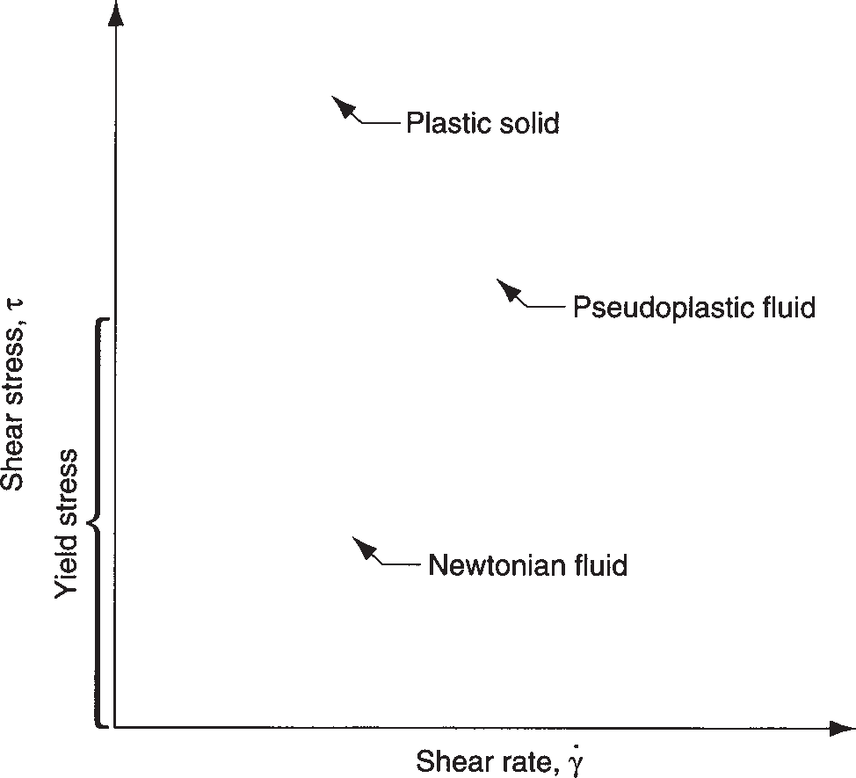

**FIGURE 3.18** Viscous behaviors of Newtonian and pseudoplastic fluids. Polymer melts exhibit pseudoplastic behavior. For comparison, the behavior of a plastic solid material is shown.

# Viscoelastic Behavior of Polymers

**3.5**

Another property that is characteristic of polymers is viscoelasticity. ***Viscoelasticity*** is the property of a material that determines the strain it experiences when subjected to combinations of stress and temperature over time. As the name suggests, it is a combination of viscosity and elasticity. Viscoelasticity can be explained with refer- ence to Figure 3.19. The two parts of the figure show the typical response of two materials to an applied stress below the yield point during some time period. The material in (a) exhibits perfect elasticity; when the stress is removed, the material returns to its original shape. By contrast, the material in (b) shows viscoelastic be- havior. The amount of strain gradually increases over time under the applied stress. When stress is removed, the material does not immediately return to its original shape; instead, the strain decays gradually. If the stress had been applied and then immediately removed, the material would have returned immediately to its start- ing shape. However, time has entered the picture and played a role in affecting the behavior of the material.

A simple model of viscoelasticity can be developed using the definition of elas- ticity as a starting point. Elasticity is concisely expressed by Hooke’s law, *s* = *Ee*, which simply relates stress to strain through a constant of proportionality. In a vis- coelastic solid, the relationship between stress and strain is time dependent; it can be expressed as

*s*(*t*) = *f*(*t*)*e* (3.27)

The time function *f*(*t*) can be conceptualized as a modulus of elasticity that depends on time. It might be written *E*(*t*) and referred to as a viscoelastic modulus. The form of this time function can be complex, sometimes including strain as a factor. Without getting into the mathematical expressions for it, the effect of the time dependency can nevertheless be explored. One common effect can be seen in Figure 3.20, which shows the stress–strain behavior of a thermoplastic polymer under different strain

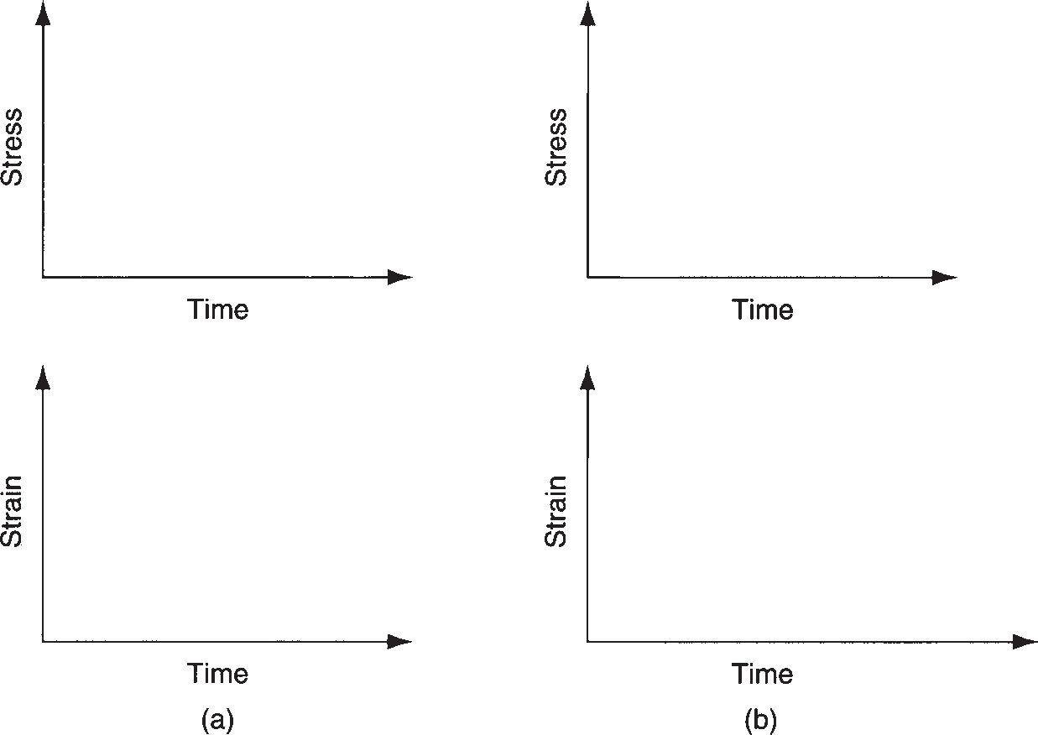

**FIGURE 3.19**

Comparison of elastic and viscoelastic properties: (a) perfectly elastic response of material to stress applied over time; and (b) response of a viscoelastic material under same conditions. The material in (b) takes a strain that is a function of time and temperature.

**FIGURE 3.20** Stress–strain curve of a viscoelastic material (thermoplastic polymer) at high and low strain rates.

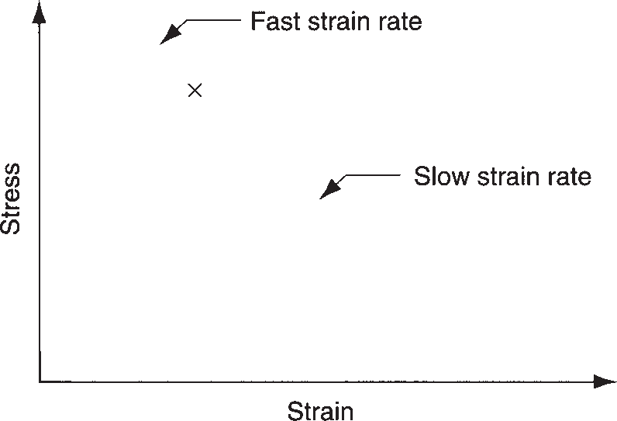

rates. At low strain rate, the material exhibits significant viscous flow. At high strain rate, it behaves in a much more brittle fashion.

Temperature is a factor in viscoelasticity. As temperature increases, the viscous behavior becomes more and more prominent relative to elastic behavior. The material becomes more like a fluid. Figure 3.21 illustrates this temperature depend- ence for a thermoplastic polymer. At low temperatures, the polymer shows elastic behavior. As *T* increases above the glass transition temperature *Tg*, the polymer be- comes viscoelastic. As temperature increases further, it becomes soft and rubbery. At still higher temperatures, it exhibits viscous characteristics. The temperatures at which these modes of behavior are observed vary, depending on the plastic. Also, the shapes of the modulus versus temperature curve differ according to the proportions of crystalline and amorphous structures in the thermoplastic. Thermosetting poly- mers and elastomers behave differently than shown in the figure; after curing, these polymers do not soften as thermoplastics do at elevated temperatures. Instead, they degrade (char) at high temperatures.

Viscoelastic behavior manifests itself in polymer melts in the form of shape memory. As the thick polymer melt is transformed during processing from one shape to another, it “remembers” its previous shape and attempts to return to that geometry. For example, a common problem in extrusion of polymers is die

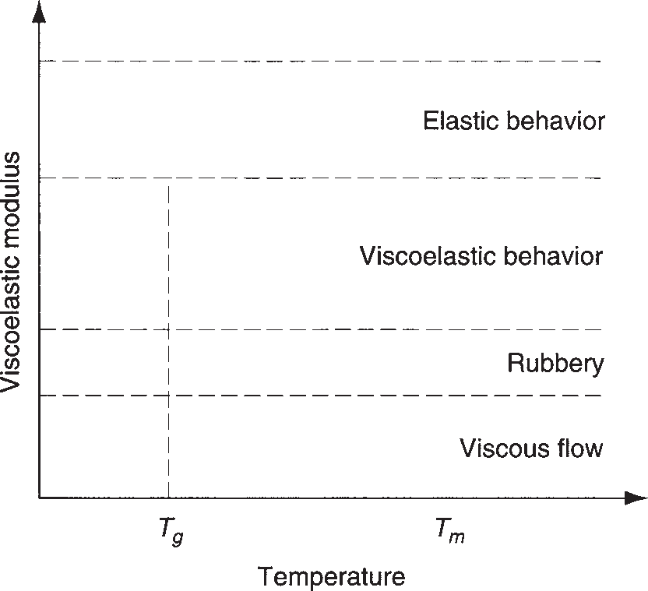

**FIGURE 3.21** Viscoelastic modulus as a function of temperature for a thermoplastic polymer.

Section 3.5/Viscoelastic Behavior of Polymers

**78**

swell, in which the profile of the extruded material grows in size, reflecting its ten- dency to return to its larger cross section in the extruder barrel immediately be- fore being squeezed through the smaller die opening. The properties of viscosity and viscoelasticity are examined in more detail in Chapter 13 on plastic-shaping processes.